Thomas’ Resume

Basic Infor

|  |  |  |  |
| --- | --- | --- | --- |
| **Name:** | **Thomas Lee** | **CV online:** | <http://yinfang-ai.top> |
| **Location:** | Shanghai China | **University:** | TianJin University of Technology&Science |
| **Phone:** | (+086)15801947029 | **Major:** | Information Tech & Calculation |
| **Email:** | cc5zhenhua@163.com | **Degree:** | Bachelor of Math Science |

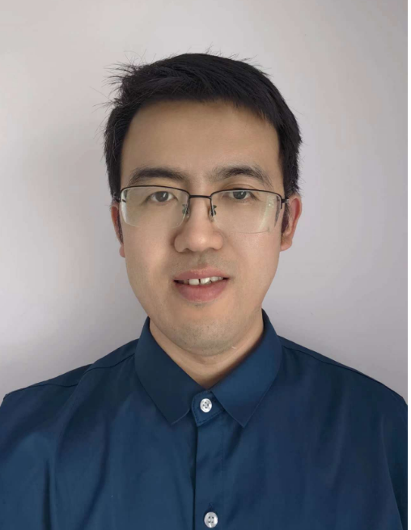

Brief-Intro

* 16 years working experience as software developer, with Full stack developing skills include reactjs , javascript/ typescript, C#, python, flask, nodejs, angular_v1, Jquery, css, sqlserver, postgrelsql, mongodb, redis, rabbitmq, Azure/AWS services, elasticSearch, d3js, grpc, signalr, websocket, oauth, restful webapi, pytorch, tensorflow experiences as well.
* CET-6 certified in university, ability to communicate and report in English.
* Have cloud infrastructure developing experience, include Azure, AWS, Aliyun. Have AWS solution architecture assistant certification.
* Worked as team Leader/project owner before. Have PMP certification, Microsoft MCP certification, China national software designer certification.
* Got annual “excellent employee” and “best mentor” honors in working experience before.
* With good basic knowledge of mathmatics for specialty in University, Have basic knowledge of machine learning/deeplearning/llm-rag with IBM pytorch deep learning skill certification on Edx.
* With experience of CI/CD infrastructure developing based on azure devops pipeline, docker, kubernetes, , powershell, helm charts, arm templates, octopus.

History

|  |  |
| --- | --- |
| **2022.06~now** | **Work in Kincentric Shanghai Senior full stack developer**  **Project-1:** Mail service web applications upgrade developing, database auto backup infrastructure  **Achievement:**   1. Developed new email management web application and code refactor from legacy windows service to Azure serverless Service. Move web pages from Angular1 framework to react in the front end, integrated AWS SES as email sender. 2. Develop new devOps CI/CD pipelines and database auto backup powershell scripts.   **Project-2:** Develop web components and application according business requirement.  **Site url:** <https://surveybuilder.modernsurvey.com/> , <https://msuite.modernsurvey.com/>  **Achievement:**  Develop new frontends web pages components with typescript & react, code developing of high performance backend web apis, develop infrastructure scripts which used in deployment process.  **Tech Stack:**  Typescript, Nodejs, React, Angular1, C#, OAuth, AWS&Azure platform services, SQL,  Powershell, redis, git, dapper. |
| **2018.05~2022.05** | **Work in iHerb.Inc Shanghai Senior Software Developer** |
|  | **Project-1:**  Develop iHerb flagship store in several ecommerce platforms, like JD, 11street, Amazon  and shopify.  **Achievement**:  Design and developed iHerb webstore UI pages in JD.com, 11street and Amazon,  Integrate of backend services. Like product warehouse/price/inventory Sync, order  processing/refund/monitor system.  Develop product management application which is used for all markets.  **Tech Stack:**  Python, flask, react, docker, kubernetes, rabbitmq, redis, mongodb, hangfire, jenkins  **Project-2:**  Company authentication/authorization system migration from identityServer to Okta  **Achievement:**  Migrate company user role/permission to new data repository.  Developed permission middleware for all web application authentication and  authorization.  **Tech Stack:**  .Netcore, identityServer, Okta service, OAuth, Git, Prometheus, swagger, Jenkins, docker |
| **2012.05~2018.05** | **Work in BeyondSoft Software Developer/ Team Leader/AssistantManager** |
|  | **Project-1:**  Marykay ecommerce system supporting and Vorwerk web application developing  **Duty:**  Develop Vorwerk web application based on WeUI, Wechat Auth and Vue.js.  Technology Support for customs. Maintnance web/desktop services.  **Tech Stack:**  WeUI, Wechat Auth, python+selenium, postman, asp.net mvc, javascript, Jquery, html5,  vuejs, Sqlserver, Websocket, Git, AWS, GRPC  **Project-2：**  ANOMS online trading strategy regression application.  **Duty:**  Developing webapi interface for a [futures](https://cn.bing.com/dict/search?q=Futures&FORM=BDVSP6&cc=cn) [contract](https://cn.bing.com/dict/search?q=Contract&FORM=BDVSP6&cc=cn) trading system named CTP.  **Technology Stack：**  C++,Java, JNI, CTP SDK, JFinal, restlet, Javascript, Tomcat, Linux(CentOS) |
| **2008.08~2012.05** | **Work in Hisoft SDET Team leader** |
|  | **Projects:**  Microsoft VisualStudio2008, Visualstudio2010, Visualstudio2012 projects  **Duty:**  As contracted software engineer working with Microsoft VisualStudio team  guys. Coding/own automation testing scripts, create quality reports, fixing testing  scripts.  **Technology Stack：**  MAUI(windows based UI testing framework). MSTest. Hyper-v,  ActiveDirectory, MS Domain, Silverlight, WPF, WCF, Maddog testing tool. |
| **2007.06-2008.08** | **Work in Achievo Software developer** |
|  | **Projects:**  Mitsubishi elevator management system for Japanese customers.  **Duty:**  Developing Mitsubishi elevator winform and JSP based management portal.  **Technology:**  Java, C#, net framework, WindowsForm, Weblogic, JSP |
| Education |  |

|  |  |  |
| --- | --- | --- |
| **Range** | **Education/Institution** | **Certification** |
| 2003-2007 | Tianjin University of Technology&Science | Bachelor of Science Degree |
| 2007 | National Software development skill examination | Software designer certification |
| 2010 | US Project Management Institute | PMP certification |
| 2011 | Microsoft MCP examination | .net&sql server MCP certifications. |
| 2024 | IBM pytorch deeplearning | Pytorch&deeplearning Skill certification. |
| 2024 | AWS Solution Architecture examination | AWS assistant solution architecture certification |

Developed a GUI image matting tools with PyQT and ModNet model.

Deployed graphrag+ollama llm models to local server.

Developed a digital human chatting application with python integrated gemma, dreamtalking and TTS technologies.

Developed a data crawling and data visualization tool with D3js

Other Items